ST. XAVIER’S COLLEGE

(Affiliated to Tribhuvan University)

Maitighar, Kathmandu



**DBMS LAB ASSIGNMENT #6**

**SUBMITTED BY:**

Pradeep Dahal

017BSCIT029

2nd Year/4th Sem

**SUBMITTED TO:**

|  |  |
| --- | --- |
| Er. Sarjan Shrestha  (Lecturer) |  |
| Department of Computer Science | |

**Lab 6**

**Relational Database Design**

Visit to site: https://edusanjal.com/ You are only required to consider two views (‘College’ and ‘Course’ in the given home page) In each of view, use information in left side vertical navigation to identify entities, attributes and relationship. Based on gathered information prepare a final report with following information:

1. ER model
2. Relation Schema representation
3. DDL script to create relation schema identified in number 2.

Note: Not required but will be useful to include few insert statements to populate few data sets in created relational database. So that we can match the query result with result presented by website for few cases.

**SOLUTION**

**ER Model**

* For ER Model, first entities and their attributes were fund out.
* Then, the relationship between the entities were determined.

1. **ER Diagram**

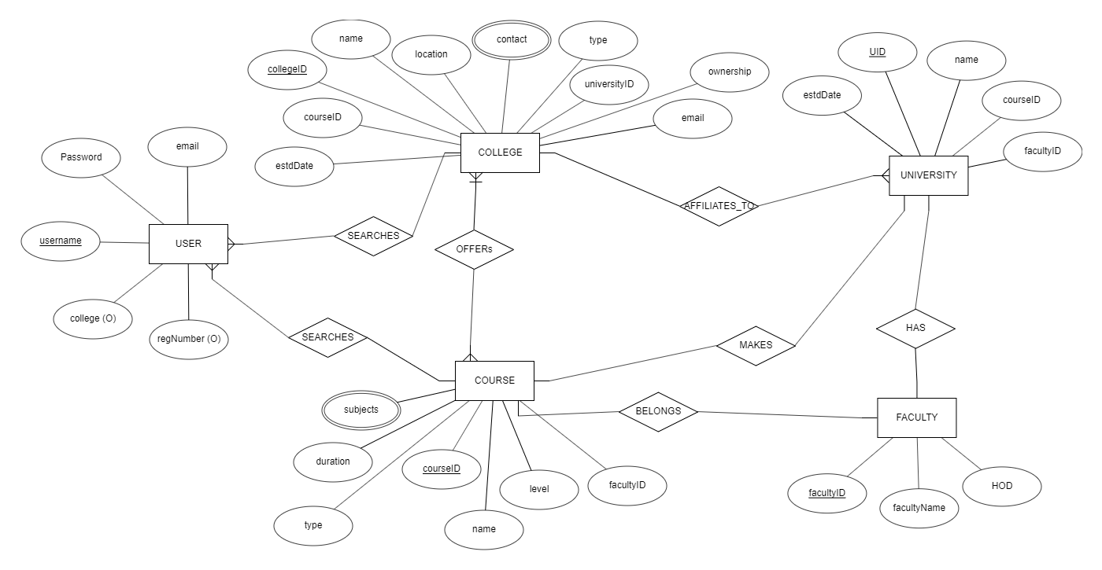

1. **RELATIONAL SCHEMA REPRESENTATION**

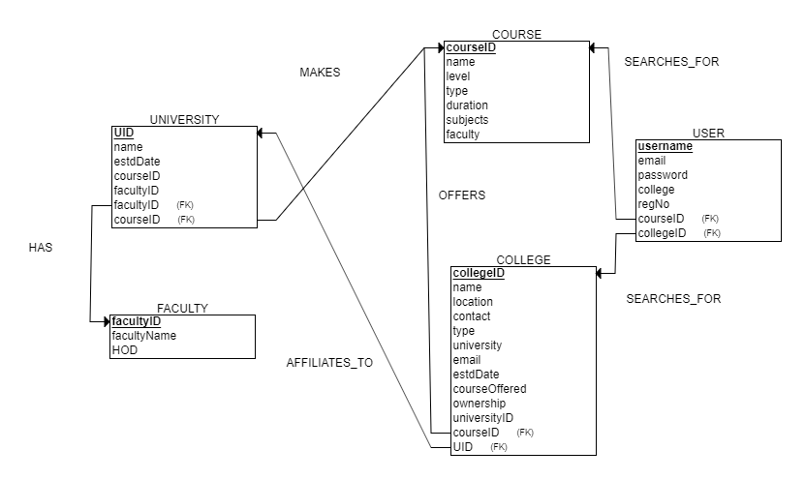

1. **DDL script to create relation schema identified in number 2.**

CREATE TABLE COURSE

(

courseID VARCHAR NOT NULL,

name VARCHAR NOT NULL,

level VARCHAR NOT NULL,

type VARCHAR NOT NULL,

duration NUMERIC NOT NULL,

subjects VARCHAR NOT NULL,

faculty VARCHAR NOT NULL,

PRIMARY KEY (courseID)

);

CREATE TABLE FACULTY

(

facultyID VARCHAR NOT NULL,

facultyName INT NOT NULL,

HOD VARCHAR NOT NULL,

PRIMARY KEY (facultyID)

);

CREATE TABLE UNIVERSITY

(

UID VARCHAR NOT NULL,

name VARCHAR NOT NULL,

estdDate DATE NOT NULL,

courseID VARCHAR NOT NULL,

facultyID VARCHAR NOT NULL,

facultyID VARCHAR NOT NULL,

courseID VARCHAR NOT NULL,

PRIMARY KEY (UID),

FOREIGN KEY (facultyID) REFERENCES FACULTY(facultyID),

FOREIGN KEY (courseID) REFERENCES COURSE(courseID)

);

CREATE TABLE COLLEGE

(

collegeID INT NOT NULL,

name VARCHAR NOT NULL,

location VARCHAR NOT NULL,

contact NUMERIC NOT NULL,

type VARCHAR NOT NULL,

university VARCHAR NOT NULL,

email NUMERIC NOT NULL,

estdDate DATE NOT NULL,

courseOffered VARCHAR NOT NULL,

ownership CHAR NOT NULL,

universityID VARCHAR NOT NULL,

courseID VARCHAR NOT NULL,

UID VARCHAR NOT NULL,

PRIMARY KEY (collegeID),

FOREIGN KEY (courseID) REFERENCES COURSE(courseID),

FOREIGN KEY (UID) REFERENCES UNIVERSITY(UID)

);

CREATE TABLE USER

(

username VARCHAR NOT NULL,

email VARCHAR NOT NULL,

password VARCHAR NOT NULL,

college VARCHAR NOT NULL,

regNo NUMERIC NOT NULL,

courseID VARCHAR NOT NULL,

collegeID INT NOT NULL,

PRIMARY KEY (username),

FOREIGN KEY (courseID) REFERENCES COURSE(courseID),

FOREIGN KEY (collegeID) REFERENCES COLLEGE(collegeID)

);